Задания к Республиканской дистанционной викторине
среди обучающихся профессиональных образовательных организаций Чувашской Республики,
приуроченной к Году народного искусства и культурного наследия в России и
к Году выдающихся земляков в Чувашии

Уважаемый участник викторины!
Ты можешь проявить творчество - сопроводить ответ иллюстрациями, ответ должен быть полным, но не более 5 предложений.
Помни, что оценивание конкурсных работ осуществляется по следующим критериям:
правильный ответ - 1 балл,
правильный полный ответ - 2 балла,
правильный полный ответ с элементами творчества - 3 балла.

Помни о сроках выполнения и сдачи ответов: 28 - 31 октября 2022 года

В ответах указывается только номер задания, шрифт Times New Roman 12.

образец оформления ответа

Викторина, приуроченная к Году народного искусства и культурного наследия в России и
к Году выдающихся земляков в Чувашии

Ф.И.О.____________
название образовательной организации________
курс___
руководитель ____________

I. From History of Russian Culture (Из истории русской культуры)

1.
2.
3.

I. From History of Russian Culture (Из истории русской культуры)

1. These works are mentioned by Herodotus, and the oldest surviving copy belongs to the XVII century. There were whole villages in Southern Dagestan, all the inhabitants of which were engaged in this craft. In the most famous of them, it is still alive today. Already in the post-war years, specialized factories appeared in the villages, but in the late 1990s there was a return to artisanal production. The XIX century brought unconventional plots and chemical dyes. Now enthusiasts are restoring the ancient drawing and technology using madder, barberry bark and walnut peel.

2. Although little is known about his life, he is considered one of the greatest Russian painters of Orthodox icons ever to have lived. He was a monk, who lived in the Trinity-St. Sergius .He painted icons and frescoes for famous Russian Orthodox churches such as Assumption Cathedral in Vladimir. His most famous work was the Trinity, which is regarded as being one of the greatest works in Russian art. Who was he?

3. He is one of main characters of Russian folk street theatre in the 18th century. He wears a red shirt and a red fool’s cap. He never loses, not even in difficult situations. Who is he?

4. Look at the monument. It is dedicated to one famous Russian song. What is the name of the song?
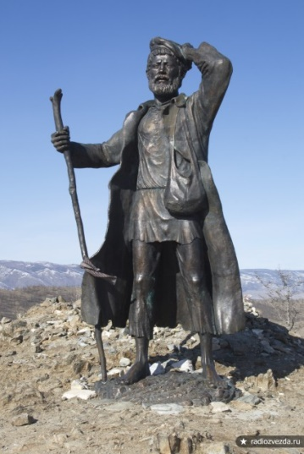

5. What or whom did the spreading of Russian theatre start with? When?

6. Who is considered to be a founder of the Bolshoi Theatre?

7. A world-known Russian composer who was awarded a Cambridge Doctor of Music degrees. He was the man who created the first classical samples of different genres in Russian music - symphony, string quartet, piano concerto, ballet, etc. Who was he?

8. His favourite words are “I don’t believe”. Who is he?

9. He played with dolls until the last day of his life. Limp toys came to life, sang, danced and performed on stage in the hands of the master. The audience idolized his performances. The soviet actor travelled almost the whole world with his theatre. Everywhere he was met with enthusiastic applause. Who is he?

10. «Katyusha»- this song needs no introduction, because the first notes will be recognized by the inhabitants of the whole world! The creators of this masterpiece are the composer Matvey Blanter and the poet Mikhail Isakosky. By the way, this is the only song that has its own museum and monument. When and where was this museum opened?

II. The country of one hundred thousand words, one hundred thousand songs and one hundred thousand embroideries (Край 100 тысяч слов, 100 тысяч песен)

1. She was sent to the Cheboksary Monastery. The monastery, to which she was brought, burned down in a fire in 1690. As the legend says, she was also guilty of commissioning the icon "The Life of Tsarevich Dimitri". Who is she?

2. Match the pictures with names of famous Chuvash fairy tales. There is one extra title (name). What Honored Artist of the Russian Federation wrote illustrations for the fairy tales presented above? Where was he born?

1 | 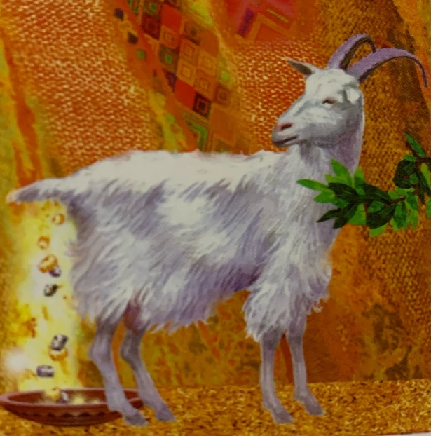 | Sharpshooting solider  Wind’s children  A Girl on the Moon  Sharapchik  Wise frog  Golden bag  Old man Uh
2 | 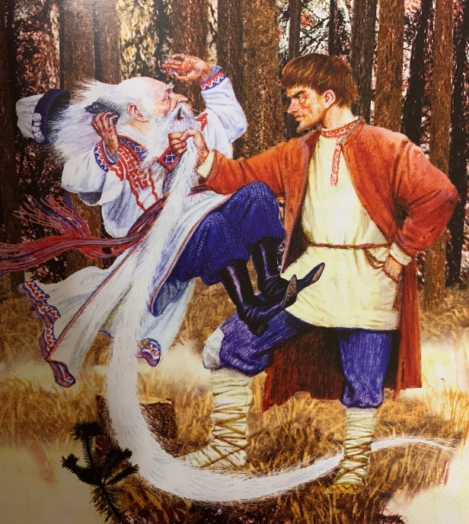
3 | 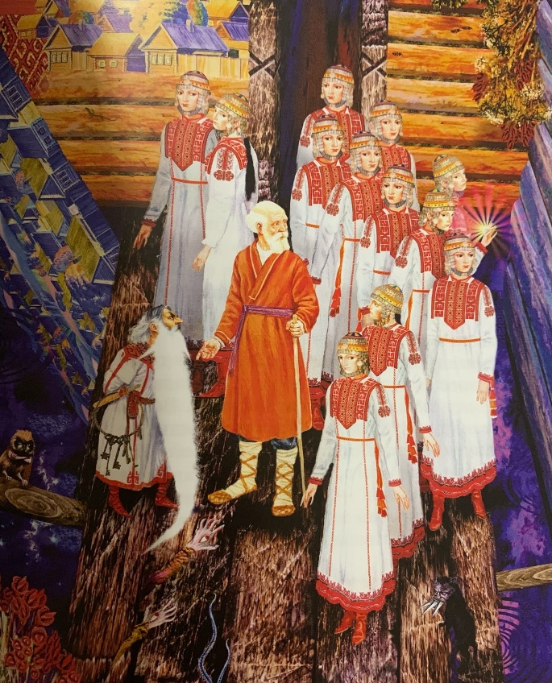
4 | 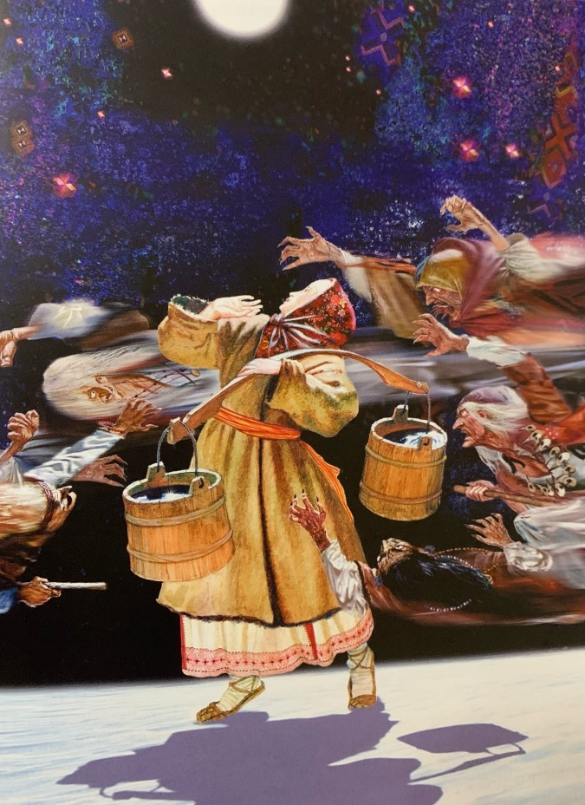
5 | 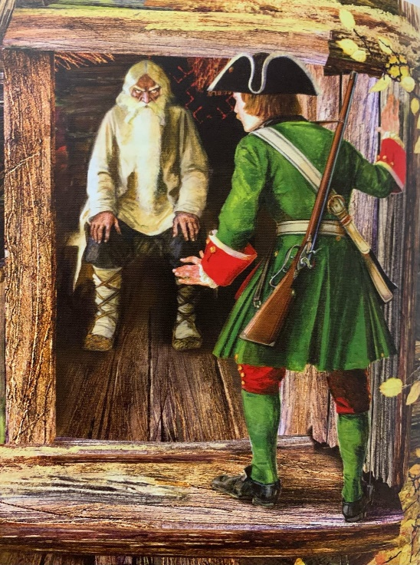
6 | 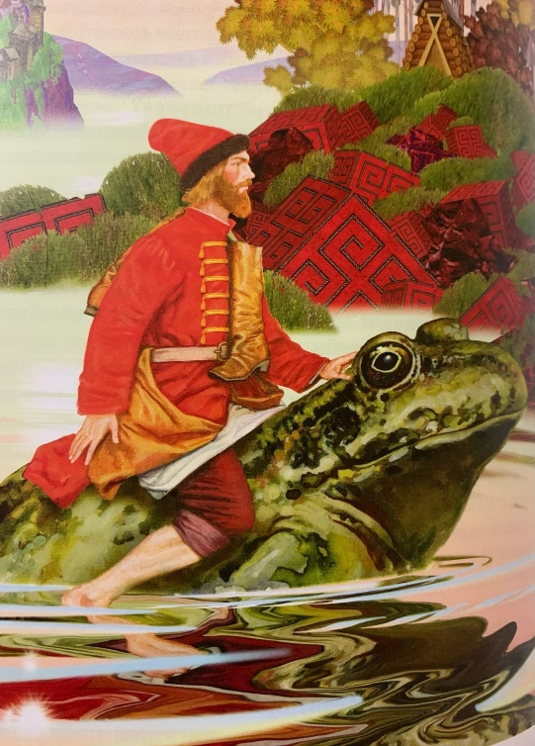

3. Their names are well-known in Chuvashia and Russia. They both finished the same school in Simbirsk. One of them wrote the poem which later was set to music. The other worked hard at the system of musical education in Chuvashia. There is a college in Cheboksary named after him. What are their names?

4. The name of this actress was well-known in the twenties and thirties of the XX century in the country. She was known as the most outstanding figure of the Chuvash national culture. The films “Sarpige” and “Black pillar” with her participation in the main role were shown in Europe and America. She starred in almost all Chuvash films created by theFilm Studio “Chuvashkino”: Mother (“Volga rebels”), Sarpige (“Sarpige”). The main roles in the theatre were Anisa (“Anisa a. Galangal”), Glafira (“Casken sorgsam” (Wolves and sheep) by Alexander Ostrovsky), Emila (Othello by W. Shakespeare). She combined her scenic activity with work on the translation of the best plays of Russian and foreign literature. Who is this actress?

5. What is Nadezhda Pavlova famous for? How is her name linked with Cheboksary?

6. Whose name is the best symbol of the renewal and soaring growth of Chuvashia in the Soviet years? In the article “From the Wooden Plough to the Stars” this person writes about countrymen who have instilled in respect for work and the working.

7. Do you know a people
In whose land a thousand songs are sung.
And a thousand colours shine
On Embroideries?
Whose words are these? Why does the author describe our Republic in such a poetic way?

8. There is a small town of Kozmodemyansk on the Volga between Nizhny Novgorod and Cheboksary. This city was included in a well-known Russian comedy, but with another name. The events that took place in this city are connected with a very spectacular game and looking for furniture. What is the name of this story and what was the name of the city in it?

9. Whose words are these: “There is no tradition without memory, no culture without traditions, no upbringing without culture, no spirituality without upbringing, no personality without spirituality and no nation without personality”?

10. Cheboksary has many monuments. The height of this monument is 46 meters, which far exceeds all other monuments in the city. What kind of sculpture is this? When was it created?

III. It’s interesting to know… (Это интересно знать)

1. In the old days in Russia there was a custom to feed a man with such kind of porridge. It contained vinegar, pepper, salt, horseradish and even mustard. When was it customary to treat a man with this unusual dish?

2. It is one of the most ancient folk crafts. By tradition, people and animals are designed without details, roughly indicating the legs, head and body. Animals have long, curved necks. Products are painted with bright colors and a simple ornament of stripes of different colors. What is it?

3. This is a Russian craft that arose at the end of the 18th century. This is a type of traditional oil painting on papier-maché products, a special mass made from cardboard, paper and glue. The craft got its name from the village near Moscow. At first lacquered army visors were created at this factory. What is the name of this craft?

4. This piece of art was composed by Pyotr Tchaikovsky. The scenario, initially in four acts was written on Russian folk tales as well as an ancient German legend. The ballet received its premiere on February 27, 1877 at the Bolshoi Theatre in Moscow? What is its name?

5. Once Rimsky-Korsakov was indignant about the fact that the director of the St. Petersburg Conservatory had a long term of his post. What is the name of the opera that the composer presented in the capital a few days later?

